**Srm Institute of science and technology**

**KattanKulathur, Chennai**  
 4th Sem



**Online Gas Booking System  
 (DBMS MINI PROJECT)**

**Team Members**

**Adarsh Kumar Bohidar****(RA2011042010083)**

**Aditya Rai(RA2011042010097)**

**Harsh Vardhan(RA2011042010082)**

**AIM:-** To implement different SQL queries to create a database for an online gas booking system

**Description**

List of Entities and its attributes

1.Customer :- This entity includes attributes like name, customer_id , address and mobile no. Here the primary key will is customer_id. This entity is to show who will be receiving the gas or book the gas.

2.Agency :- This entity includes attributes like name, Agency_id. Its is the entity that receives the order and here the primary key is Agency_id.

3.Stock :- This entity includes attributes quantity, type, batch_no. and primary key here is batch_no.

4.LPG :- This entity includes attributes gid, weight, type and primary key is gid.

5.Bill :- This entity includes attributes Bill_id , Amount and customer_id where primary key is Bill_id and the foreign key is Customer_id

**CREATION OF A NEW USER**

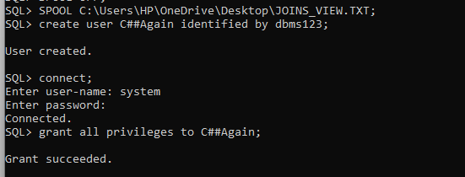

**CONNECTING TO NEW USER AND GIVING PRIVILEGES**

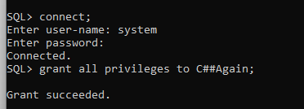

**ENTITY RELATION DIAGRAM FOR ONLINE GAS BOOKING SYSTEM:**

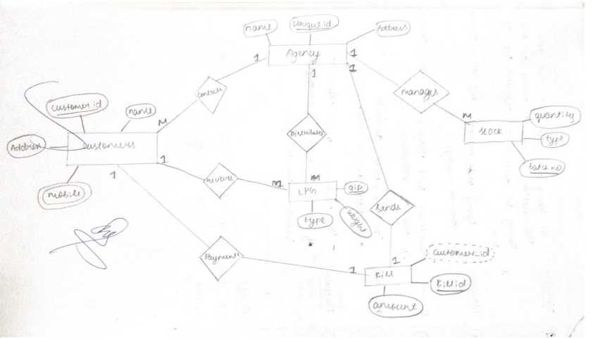

**CREATING NECESARRY TABLES:**

CUSTOMERS

create table customers(

Customer_id int NOT NULL,

Name varchar(200),

Address varchar(200),

Mobile int NOT NULL,

PRIMARY KEY(Customer_id));

AGENCY

create table agency(

Agency_id int NOT NULL,

Name varchar(200),

PRIMARY KEY(Agency_id));

STOCK

create table stock(

Batch_no int,

type varchar(10),

quantity int,

PRIMARY KEY(Batch_no));

BILL

create table Bill(

Bill_id int,

Amount int,

Customer_id int,

PRIMARY KEY(Bill_id),

FOREIGN KEY(Customer_id) REFERENCES customers(Customer_id));

LPG

create table LPG(

Gid int,

weight varchar(5),

type varchar(5));

**INSERTING DATA INTO THE CREATED TABLES:**

**1.INSERTING INTO CUSTOMERS TABLE**

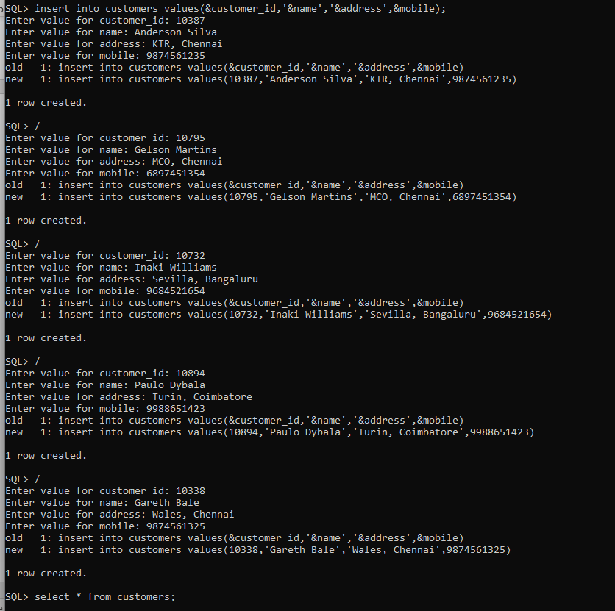

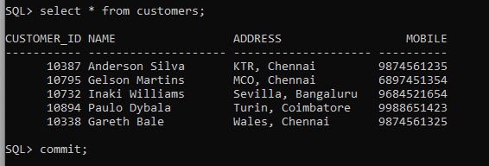

**2.INSERTING INTO BILL TABLE**

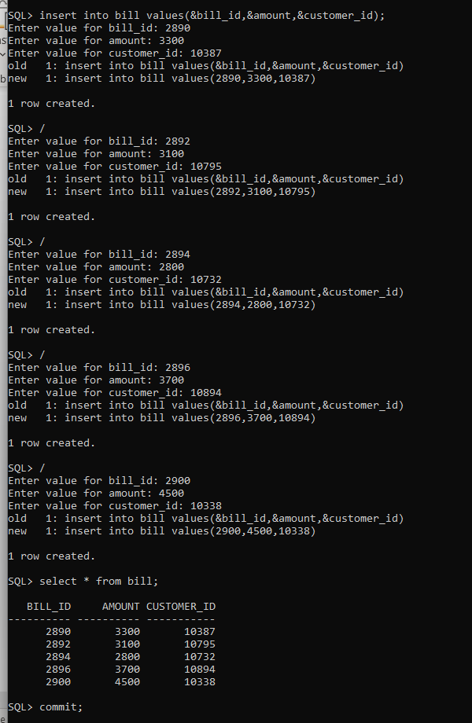

**3.INSERTING INTO STOCK TABLE :**

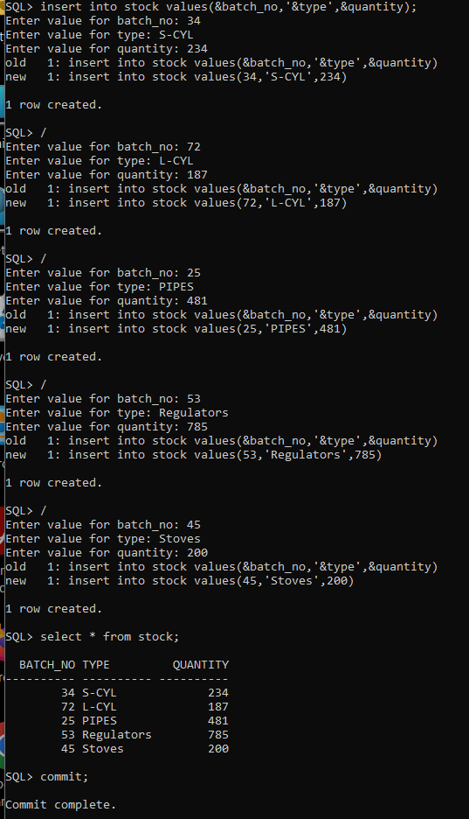

**4.INSERTING INTO LPG TABLE:**

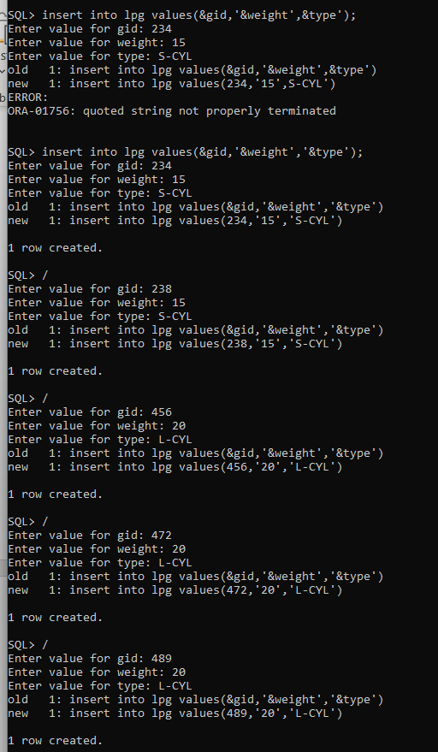

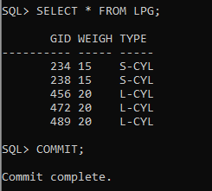

**5.INSRTING INTO AGENCY TABLE:**

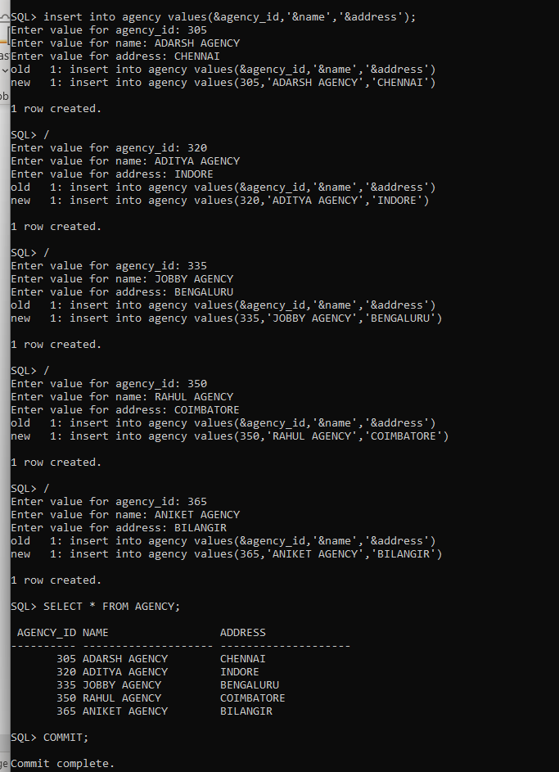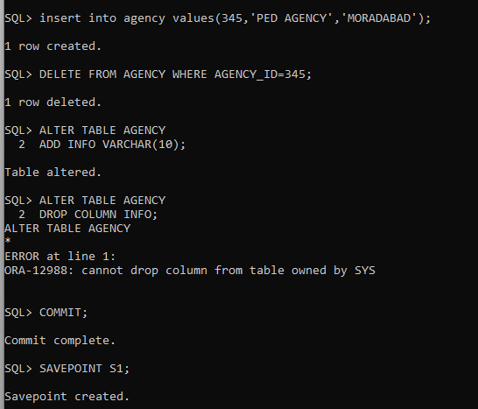

**TCL COMMANDS**

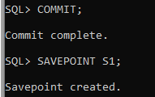

**BUILT-IN FUNCTIONS**

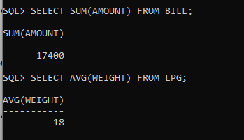

**SET OPERATORS**

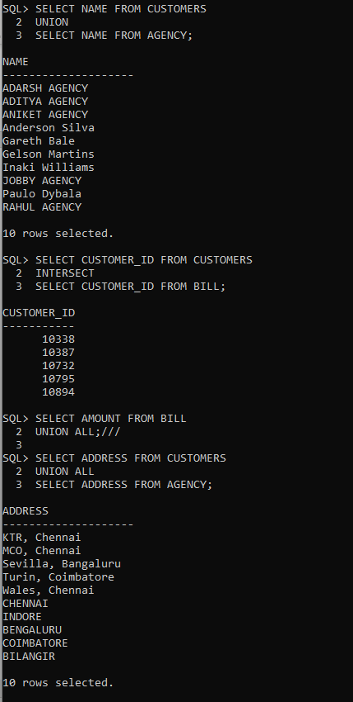

**SUB QUERY**

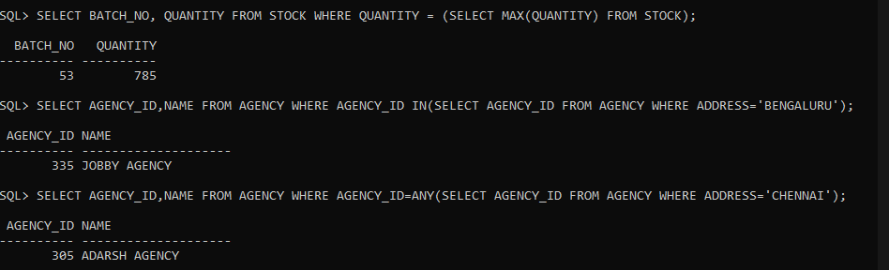

**CREATING DIFFERENT VIEWS WITH JOIN FOR THE DATABASE:**

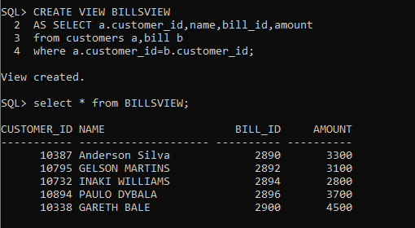

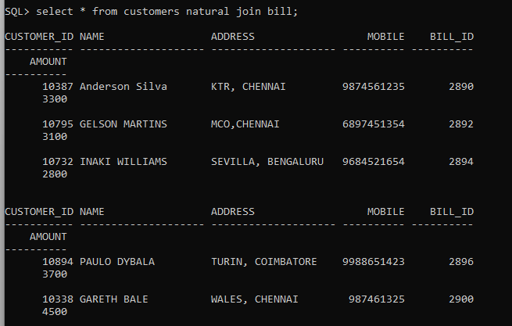

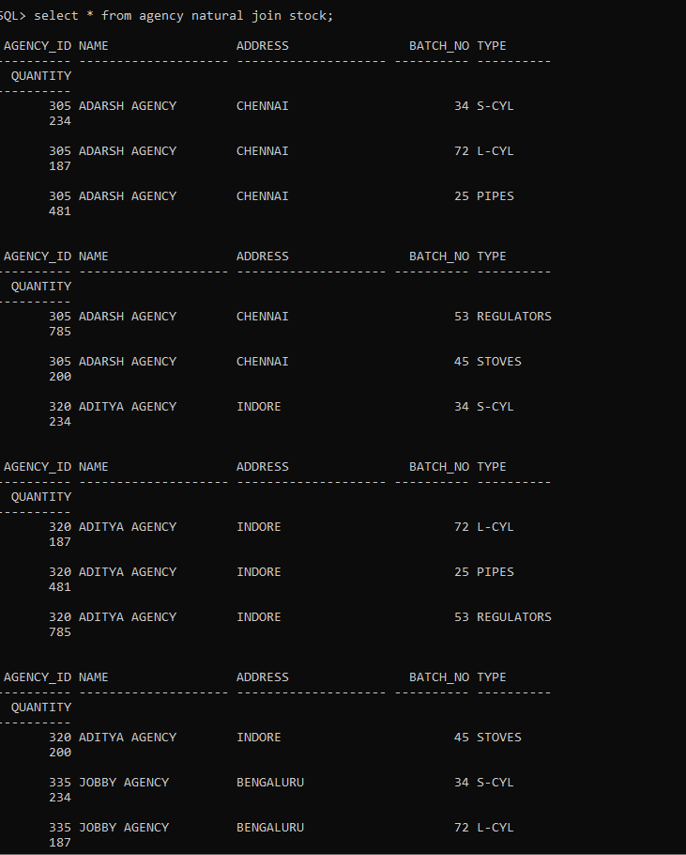

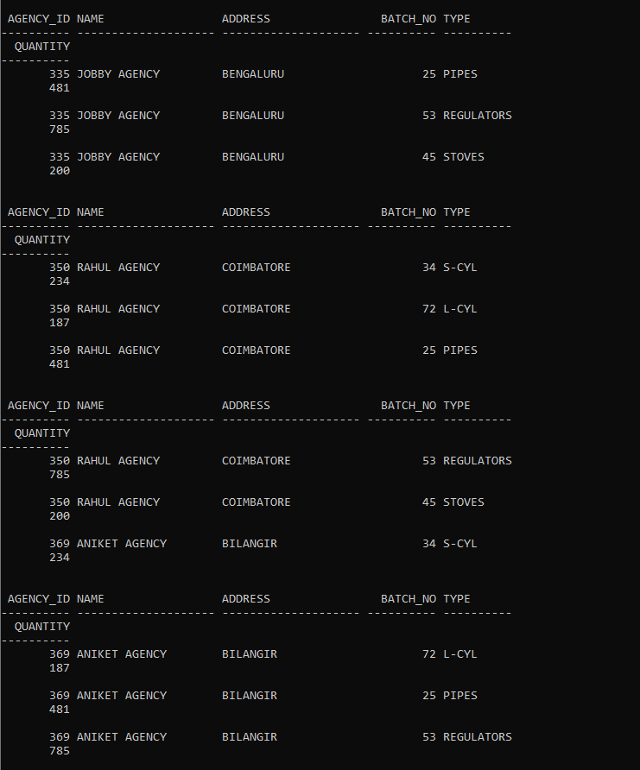

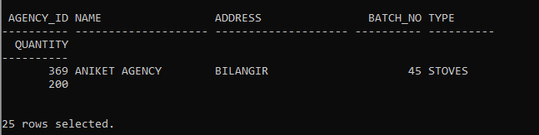

**PL/SQL**

**TRIGGER:-**

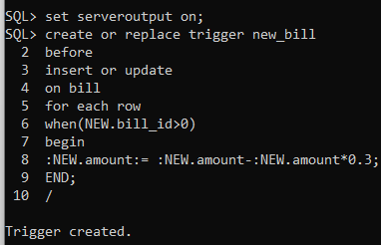

OUTPUT:-

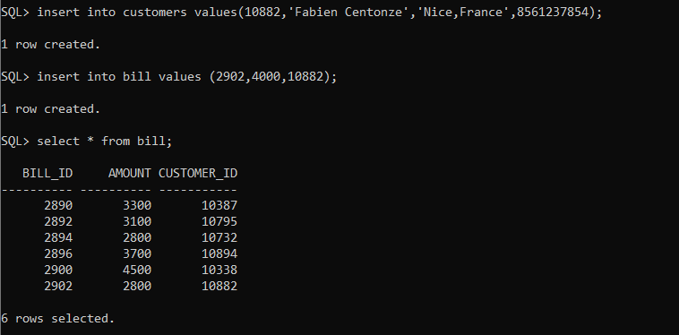

**PROCEDURE WITH EXCEPTION HANDLING:-**

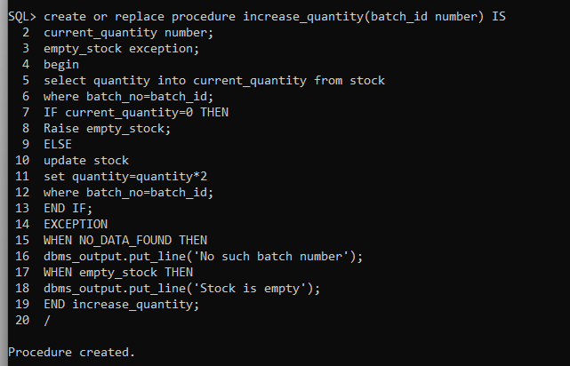

**OUTPUT:-**

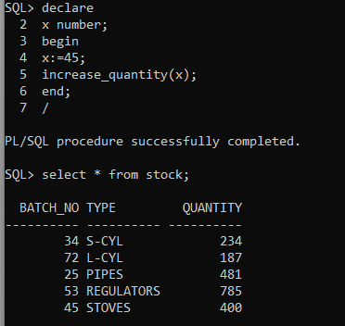

**FUNCTION:-**

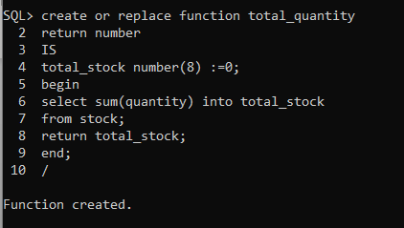

**OUTPUT:-**

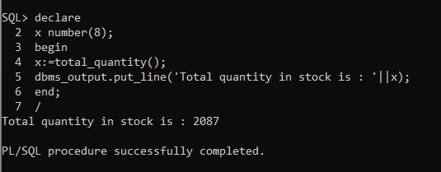

**CURSOR:-**

**i)EXPLICIT CURSOR**

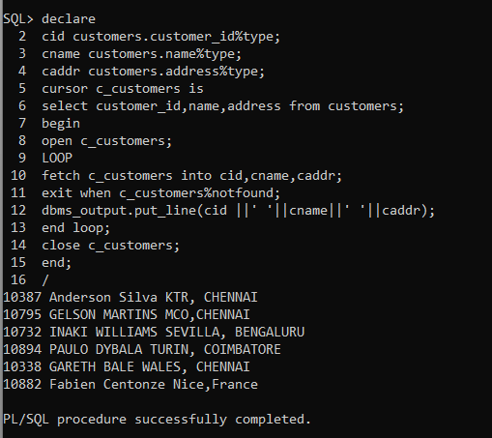

**ii)IMPLICIT CURSOR**

